Table of contents

Polymer Pipe Technology iNTERpipe

Section Page
Introduction /Company info 2

Products 3

Benefits 4

Standards 6

Applications 8

Jacking Pipe 9

Design Basis 12

24” Jacking Pipe Analysis 17

Direct Bury 19

Slipline Comparison 21

Flow Rate 23

Test Data 24

36” Design Calculations 25

PPT Specifications - Pipe 28
- Microtunnel 35
- Manhole structures 37

Supplemental Information 42

Corrosion Resistance Chart 62

iNTERpipe

polymer pipe

TECHNOLOGY

Polymer Pipe Technology (PPT), is a manufacturer of reinforced polymer concrete pipe and structures called iNTERpipe. The iNTERpipe products are ideal for wastewater industry applications due to the inherent corrosion resistance and increased structural strength of the polymer concrete matrix.

Headquartered in Des Moines, Iowa, Polymer Pipe Technology (PPT) has an extensive history of manufacturing corrosive resistant large monolithic polymer concrete structures of various sizes and shapes for industries ranging from petrochemical, pulp & paper, mining & refining of non-ferrous metals…etc.

Utilizing the performance benefits of polymer concrete, PPT offers products that are highly corrosion resistant with strength properties that exceed those of similar conventional concrete pipe. PPT brings to the market products made of technically advanced materials while meeting and/or exceeding industry standards.

PPT’s manufacturing is similar to conventional wet cast concrete products utilizing all of the same processing technology. The primary difference being the use of resin as the binder in place of Portland cements.

The following is PPT’s list of manufactured products for the wastewater industry.

Direct Bury Pipe:
- Cylindrical pipe structures.
- Nominal diameters of 18 inches to 144 inches.
- Lengths consisting of standard 8 and 10 feet. Depending on size and weight.
- Custom lengths consisting of 12 and 20 feet. Depending on size and weight.
- Joint will consist of a standard single step push fit design.
- Joint will be fitted with a rubber gasket to ensure a leak proof assembly.
- Selected to meet ASTM C 443
- Joint can be manufactured with a traditional bell and spigot design.

Jacking Pipe:
- Cylindrical pipe structures.
- Nominal diameters of 18 inches to 144 inches.
- Lengths consisting of 8 and 10 feet up to 78 inch diameter. Above 78-inch diameter the length will be determined per weight and size calculations.
- Joint will consist of a standard single step push fit design.
- Joint will be fitted with a rubber gasket to ensure a leak proof assembly. Selected to meet ASTM 1208-95.
- A press board compression ring will be utilized to offer uniform pressure distribution during the jacking process.
- Flush bell Stainless Steel or FRP coupling ring is used to complete the joint assembly per project requirements.

- Manholes, Interceptor Structures, Wet Wells, Lift Stations and Panelized Systems:
- Manhole structures – standard 48 inch, 60 inch and custom sizes.
- Custom design products – PPT will manufacture custom-engineered structures per customer specification.

Reinforcement:
- All iNTERpipe utilizes the same steel reinforcement used in conventional concrete pipe manufacturing per ASTM C 76.

All iNTERpipe product is sampled and tested according to ASTM and industry standards.
- See PPT Standard Specification for Polymer Concrete Pipe.

Testing Procedures:
- PPT utilizes Maxim Technologies Incorporated / Stork Southwest Labs as the independent third party testing agency / facility.

What is polymer concrete?
Polymer concrete is similar to conventional concrete in that it contains selected blends of aggregates and fillers which are held together utilizing a binder. Conventional concrete uses a combination of cement and water for the binder.

In polymer concrete the binder is a high strength, corrosion resistant, thermosetting resin. This resin system requires a curing agent (catalyst) which when combined with the resin, transfers the resin and curing agent from a liquid to a solid thermoset polymer) which bonds to the aggregate, various fillers and internal reinforcement.

What is iNTERpipe ---

Why Polymer Pipe Technology ---
Polymer Pipe Technology was developed to meet the severe operating conditions in the wastewater industry. Traditionally, wastewater infrastructures are constructed using reinforced concrete, clay, brick and /or steel for pipe, manholes and associated structures. All of which are subject to corrosion, installation and/or maintenance problems. For many years the industry has needed a product that could combat the numerous infrastructure problems.

iNTERpipe polymer concrete products offer a solution to this need.

iNTERpipe Advantages
Because iNTERpipe is manufactured utilizing advanced polymer concrete technology, there are inherent advantages that iNTERpipe can offer over conventional concrete and other competitive products. To make iNTERpipe more user friendly, it is manufactured utilizing the standard specification guidelines for reinforced concrete.

Corrosion Resistant Because iNTERpipe is made of polymer concrete, the matrix is corrosion resistant throughout the entire wall thickness. In the event that iNTERpipe is ever chipped or marred, this corrosion barrier will remain intact. Thus ensuring a long maintenance free life. INTERpipe can be utilized in environments with pH ranges from 1 to 13. Additional coatings, liner or barriers are unnecessary.

Light Weight due to the advanced strength characteristics of iNTERpipe, PPT can produce lighter weight parts through a reduction in wall thickness – when compared with traditional reinforced concrete.

Conventional Reinforcement iNTERpipe utilizes the same type of steel reinforcement used in conventional concrete pipe ASTM standards.

Non-porous & Non-Absorbent iNTERpipe’s dense mix design eliminates a connective pore structure. Therefore, solutions are unable to be absorbed or leached through the material. Again, eliminating the need for any additional coatings, liners, or barriers.

Technical Expertise With decades of polymer concrete experience, Polymer Pipe Technology has the knowledge to engineer iNTERpipe product to suit any need. Our engineers and sales consultants maintain close contact with a project from beginning to end.

Low Environmental Impact Due to the inert nature of polymer concrete, there is no concern for any negative impact on the environment.

iNTERpipe Features –

High strength to weight ratio
Precise dimensional tolerances
High compressive strength for higher jacking loads means longer drives
Higher factor of safety
Precision molded square ends for uniform axial loading
Increased tensile strength
Proven joint design

iNTERpipe Physical Property Design Range

Compressive Strength
8,000psi to 14,000psi

Flexure Strength:
3,000psi to 4,000psi

Tensile Strength:
1,200psi to 1,600psi

iNTERpipe Reinforcement
In keeping with industry standards, PPT has chosen to utilize steel reinforcement as the standard for iNTERpipe. INTERpipe reinforcement design follows ASTM C-76, Standard Specifications for Reinforced Concrete Culvert, Storm Drain, and Sewer Pipe. Additionally, PPT designs using ASTM C-1417 & C-1479 Direct Design Standards.

iNTERpipe Quality Control –

Raw Materials Inspection, sampling and testing of raw materials is a requirement that will contribute to a quality end product. Resin, reinforcement and aggregates are systematically and randomly monitored to ensure compliance within PPT specifications.

Manufacturing Quality Assurance is paramount at PPT. Standardized written manufacturing procedures, detailed quality assurance records, and on-time deliveries instill customer confidence and satisfaction in iNTERpipe.

PPT utilizes a sophisticated process control operation in the manufacture of iNTERpipe – a means of verifying Quality and eliminating variables that can contribute to manufacturing error.

iNTERpipe Standards –

ASTM C-76-95a:
Standard specification for reinforced concrete culvert, storm drain, and sewer pipe.
ASTM C-301-93:
Standard test methods for vitrified clay pipe.
ASTM C-307-94:
Tensile strength of chemical- resistant mortars, grouts, and monolithic surfacing.
ASTM C-361-89b:
Standard specifications for concrete pipe using o-ring or profile gasket designs.
ASTM C-443-85a:
Standard specifications for concrete pipe using o-ring or profile gasket designs.
ASTM C-497-95a:
Standard test methods for concrete pipe, manhole sections, or tile.
ASTM C-506-95a
Standard specification for reinforced concrete arch culvert, storm drain, and sewer pipe.
ASTM C 507 – 98
Standard Specification for Reinforced Concrete Elliptical Culvert, Storm Drain, and Sewer Pipe
ASTM C-579-91:
Compressive strength of chemical-resistant mortars, grouts, monolithic surfacing, and polymer concretes.

ASTM C-580-93
Flexural strength and modulus of elasticity of chemical-resistant mortars, grouts, monolithic surfacings, and polymer concretes.
ASTM C-850
Standard specification for Precast Reinforced Concrete Box Sections for Culverts, Storm Drains, and Sewers with Less Than 2 ft of cover Subjected to Highway Loadings
ASTM C-924-89:
Standard practice for testing concrete pipe sewer lines by low-pressure air test method.
ASTM C-1208-95:
Standard specification for vitrified clay pipe and joints for use in jacking, sliplining, and tunnels.
ASTM C-1214-94
Standard test method for concrete pipe sewer lines by negative air pressure (vacuum) test method.
ASTM C-1417 - 00
Standard Specification for Manufacture of Reinforced Concrete Sewer, Storm Drain, and Culvert Pipe for Direct Design
ASTM C-1479 - 01
Standard Practice for Installation of Precast Concrete Sewer, Storm Drain, and Culvert Pipe Using Standard Installations.

APPLICATIONS

Jacking Pipe

Direct Bury Pipe

Slipline Pipe

Manholes & Other Structures

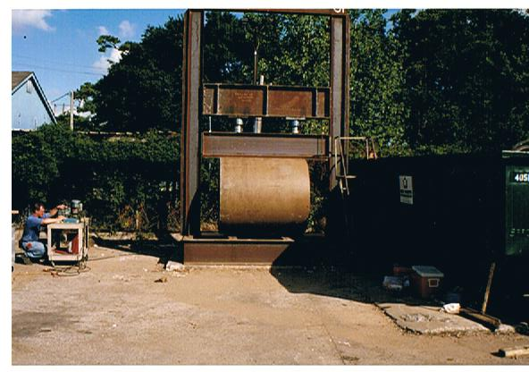

iNTERpipe steel reinforced polymer concrete jacking pipe

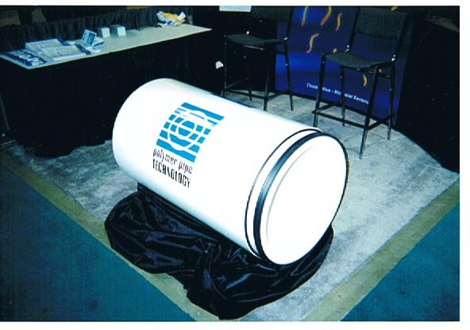

Hydrotesting at Maxim Southwest Labs

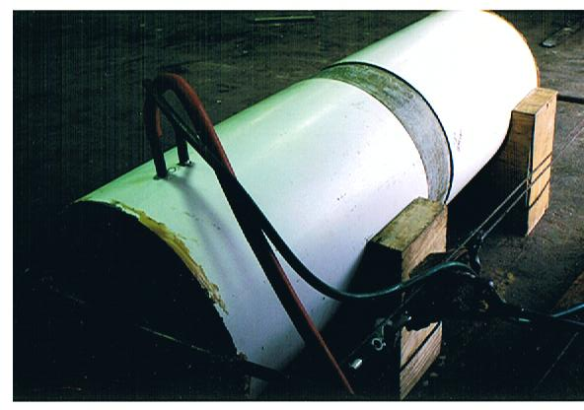

Jacking Pipe
Allowable Loads

Nominal Diameter Wall Thickness (inches) Jacking Load Tons
24 | 2.25 | 150
27 | 2.5 | 210
30 | 2.75 | 270
36 | 2.75 | 330
42 | 2.75 | 380
48 | 3.00 | 500
54 | 3.75 | 770
60 | 4.25 | 1020
66 | 5.50 | 1550
72 | 6.00 | 1880
78 | Design by project | *
84
90
96
- Jacking forces greater than 1880 tons are probably limited by the ability to construct economical reaction structures rather than the strength of the pipe.

The loads have been based upon an Fc¹ of 12,000 psi with an allowable compressive stress of 4,000 psi.

Jacking strength calculations are based on the confined core of concrete.
The concrete in the clear cover was not used. Example: the pipes with a 3” wall were based on a 2” x 48” x 3.14 = 301 in. area of concrete. Similarly the 3.75” is based on a 2.75” x 54” x 3.14 = 466 sq. in. area.

Test data prepared by MAXIM Technologies, Inc.

Design Basis and performance Testing of Polymer Pipe Technology’s 24-inch Polymer Concrete Pipe.

Introduction
The purpose of this document is to describe the design basis and subsequent performance testing of Polymer Pipe Technology Inc.’s 24-inch diameter pipe. The design basis is presented first, followed by an evaluation of the D-Load tests conducted by Maxim Technologies, Inc.’s Houston, Texas office and analyzed by their Austin, Texas office.

Design Requirements
The objective of the design was to develop a pipe wall thickness and reinforcement schedule that will meet or exceed the strength requirements of ASTM C-76-95a. “Standard Specification for Reinforced Concrete Culvert, Storm Drain, and Sewer Pipe”. The standard is referred to as C-76 throughout the remainder of this document.

Section 7.2 of C-76 defines the requirements for “modified or Special Designs”. The specific requirements of these alternative designs are provided in Sections 7.2.2 and 7.2.3, these sections are quoted in their entirety below:

7.2.2 Such modified or special designs shall be based on rational or empirical evaluations of the ultimate strength and cracking behavior of the pipe and shall fully describe to the owner any deviations from the requirements of 7.1. (Author’s note: Section 7.1 is the design tables with wall thicknesses and reinforcing schedules). The descriptions of modified or special designs shall include the wall thickness, the concrete strength, and the area, type, placement, number of layers, and strength of the steel reinforcement.

7.2.3 The manufacturer shall submit to the owner proof of the adequacy of the proposed modified or special design. Such proof may comprise the submission of certified three-edge-bearing tests already made, which are acceptable to the owner or, if such three-edge-bearing tests are not available or acceptable, the manufacturer may be required to perform proof tests on sizes and classes selected by the owner to demonstrate the adequacy of the design.

The strength requirements under C 76 for 24-inch diameter Class IV pipe are a cracking D-load of 4000 pounds per linear foot, and an ultimate D-load of 6000 pounds per linear foot. The strength requirements under C 76 for 24-inch diameter Class V pipe are a cracking D-load of 6000 pounds per linear foot, and an ultimate D-load of 7500 pounds per linear foot.

Design Basis
Preliminary Design

The initial cross sections were designed using the ultimate strength approach as in conventional reinforced concrete design. Since the purpose was to develop a design that would meet an ultimate load test, no capacity reduction factors or load amplification factors were used in the analysis. However conservative values for the ultimate compressive strength of the polymer concrete (F_{c}), and the yield stress of the steel (F_{y}).

Cross sectional bending moments were determined from the following relationship:

Bending Moment at Crown and Invert (Maximum +Moment):

M+ = 0.318 * D * R

where M+ is the maximum positive moment per foot of length
D is the D-Load per foot of length
R is the pipe radius

Bending Moment at Spring Lines (Maximum –Moment)

M- = -0.1817 * D * R

where M- is the maximum negative moment, and the other terms are defined as for M+

These expressions are from Advanced Strength of Materials, by Boresi, Sidebottom, Seely, and Smith. Third Edition, John Wiley, 1978. Page 360.

The initial design for the pipe indicated a wall thickness of 2.25 inches, with W20 sire placed on 6-inches on center. This resulted in a circumferential steel area of 0.40 sq. inches per foot of pipe length. The resulting moment capacity was:

M= pbd²f_{y}(1-0.59(pf_{y}/f_{c}))

where:
M is the moment capacity
p is the steel ratio (0.40/12x1.125 = 0.0296)
b is the unit width (12–inches)
d is depth to steel (1.125)
f _{y} is the yield stress of the steel (57,000 psi)
f_{c} is the ultimate compressive strength of the concrete (8000 psi)
The resulting capacity is 22,400 in-lbs or 1.87 foot-kips. This in turn corresponded to a D-Load of 5,870 lbs./ft. versus the required ultimate D-Load of 6000 lbs/ft. for Class IV pipe. Given the conservative assumptions in the design method this was viewed as a good starting point.
Design Basis

Polymer Pipe Technology utilizes a polymer concrete mix design which produces, in testing, an average compressive strength of 10,800 psi with a standard deviation of 600 psi. This allows the use of a specified compressive strength (f_{c}) of 9300 psi in accordance with the guidelines of the American Concrete Institute (ACI). The workability of the mix allows for placement around steel as close as 2-inches on center. This allowed for the use of a smaller wire size, with a more uniform distribution of the reinforcement. Since a final wire size and type were selected the yield stress (f_{y}) was set at 65,000 psi. The design tested therefore had the following properties:

Wall Thickness: 2.25”
Concrete Strength: 9300 psi
Steel Area: 0.42 sq. inches per foot
Steel Type: ASTM A 82 f_{y} = 65,000 psi for circumferential steel
F_{y} = 56,000 psi for longitudinal steel
Placement: Wire Fabric 2 x 8 Mesh, W7 x W3
Layers: Single Layer to be placed at center (placement error of up
to 0.25 inches inside O.K.

The resulting moment capacity is:

M= pbd²fy (1-0.59(pfy/fc))

Where:
M is the moment capacity
p is the steel ratio (0.42/12X1.125=0.0311)
b is the unit width (12-inches)
d is depth of steel (1.125-inches)
fy is the yield stress of the steel (65,000 psi)
fc is the ultimate compressive strength of the concrete (9300 psi)

The resulting capacity is 26,800 in-lbs or 2.23 foot-kips. This in turn corresponded to an ultimate D-Load of 7,100 lbs./ft. versus the required D-Load of 6000 lbs/ft. for Class IV pipe, and is close to the 7500 lbs/ft. required for Class V pipe.

Test Results

Five 4-foot long sections of 24-inch polymer concrete pipe were provided to Maxim’s Houston, Texas Laboratory for testing. The test results are summarized below.

Sample I.D. | Load and Deflection to Produce 0.01-inch crack | Ultimate Load and Deflection
Sample 1* | 8,570 lbs/ft  0.270-inches deflection | 15,200 lbs/ft  0.900-inches deflection
Sample 2* | 5,940 lbs/ft  0.255-inches deflection | 9,816 lbs/ft  1.050-inches deflection
Sample 3 | 7,190 lbs/ft  0.200-inches deflection | 10,230 lbs/ft  0.650-inches deflection
Sample 4 | 6,910 lbs/ft  0.220-inches deflection | 12,440 lbs/ft  0.835-inches deflection
Sample 5 | 6,910 lbs/ft  0.250-inches deflection | 11,890 lbs/ft  0.960-inches deflection
Average | 7,110 lbs/ft  0.239-inches deflection | 11,920 lbs/ft  0.879-inches deflection

*Note Samples 1 and 2 were used to fine-tune the vibration levels. Samples 3, 4, & 5 used the vibration level selected based upon casting Samples 1 & 2.

The test results for each sample are attached.

Summary and Conclusions

The existing 24-inch design is certainly suitable for use as Class V pipe. The performance exceeds the design assumptions due to the following reasons:

- The predicted moments are based upon elastic theory. Since the polymer concrete and steel allow for significant redistribution of stress at the on set of yielding, more of the structure is able to resist the peak load.

- The very high tensile stresses that can be carried by the polymer concrete are not accounted for in standard reinforced concrete design applications.

- The use of minimum strength properties also understates the strength of the pipe. Repeating the calculations using the average strengths of f_{c}=10,800 psi, and f_{y}=80,000 psi yields an ultimate moment capacity of:

Test Data prepared by MAXIM Technologies, Inc
Continue from number three of the previous page.

M= pbd²f_{y}(1-0.59(pf_{y}/f_{c}))

Where:
M is the moment capacity
p is the steel ratio (0.42/12X1.125=0.0311)
b is the unit width (12-inches)
d is depth to steel (1.125-inches)
f_{y} is the yield stress of the steel (80,000 psi)
f_{c} is the ultimate compressive strength of the concrete (9300 psi)

The resulting capacity is 32,650 in-lbs or 2.72 foot-kips. This in turn corresponds to an ultimate D-Load of 8,560 lbs/ft. This is approximately midway between the 0.01-inch cracking and ultimate loads measured in the test.

Test Data prepared by MAXIM Technologies, Inc.

POLYMER CONCRETE PIPE
24 – Inch Diameter Jacking Pipe Analysis

Introduction:

These calculations have been prepared by Maxim Technologies, Inc. for Polymer Pipe Technology. The purpose of the calculations is to determine the expected performance of PPT’s 24-inch Diameter jacking pipe constructed of polymer concrete. The numbers in parentheses at the end of each section are applicable to the special case of a 25-inch diameter pipe with a wall thickness of 2.25-inches.

Assumptions:

The jacking pipe will have a nominal inside diameter of 24-inches. The wall thickness has been selected as 2.25-inches. Material properties are:

Ultimate Compressive Strength (f_{c}) = 9300 psi
Maximum Tensile Strength (f_{t}) = 2000 psi
Modulus of Elasticity = 1,300,000 psi

Safe Jacking Load:

The safe jacking load (assuming a safety factor of 3) can be determined by computing the cross sectional area, moment of inertia, and anticipated maximum eccentricity of the load. The stress in the pipe is given by:

O = P/A_{c} + Pcc/j
Where:
P = Jacking Force
A_{c} = Cross Sectional Area
A_{c} = j תּ (R_{o}² - R_{i}²)
R_{o} = Outer Radius (14.25 – inches)
R_{I} = Inner Radius (12- inches)
The resulting value for A_{c} is 185 in.² (192 in.² for 25-inch pipe)
e = eccentricity of jacking force. (1.75”)
c = distance to extreme fiber (14.25 – inches) (14.75 in. for 25-inch pipe)
I = Moment of inertia
I = j תּ (R_{o}^{4 –} R_{i}⁴)/4
The resulting value of I is 16,100 in.⁴ ( 18,000 in.⁴)

thus:
O = 0.00695 P (P in pounds, o in psi.) (0.00664 for 25-inch pipe) or:
p = 144 o (P = 150 o for 25-inch pipe)

Setting o to 3100 psi, yields P = 446,400 pounds or 223 tons. (yields P = 465,000 pounds or 232 tons for 25-inch pipe.)

Stresses at The Joints During Jacking:

Theoretically the joints should provide nearly the same strength as the pipe wall. The minor reduction in wall thickness is offset by allowing higher local stresses. The higher stresses will be spread throughout the wall thickness within a length equal to one to three pipe wall thicknesses.

Deflection During Joint Testing:

The joints are to be tested using ASTM C 1208. This test calls for the application of a direct shear at the joint. The shear force to be applied is 50 pounds per inch of pipe diameter, or a total force of 1200 lbs. for the 24-inch pipe. The force is applied over a 12-inch length of pipe immediately adjacent to the joint. The ASTM C 1208 method is more challenging than the C 497 method because the pipe is actually under load. The C 497 method places no load on the pipe.

The deflection due to this extremely small load (the pipe self weight is approximately 190 pounds per foot) should be unobservable.

Test Data prepared by MAXIM Technologies, Inc.

Direct Design

Reinforcement Requirements

Design Parameters:

Concrete Compressive Strength = 9,000 psi
Reinforcing yield strength = 65,000 psi
Reinforcing cover = 1-inch
Installation in accordance with ASTM C 1479
Manufacture in accordance with ASTM C 1417

Diameter | Wall  Thickness | Installation  Type | Fill  Height | A_{SI}  (In²/ft) | A_{SO}  (In²/ft)
24 | 2.00 | 2 | 20 | 0.100
24 | 2.00 | 2 | 10 | 0.216
24 | 2.00 | 2 | 20 | 0.322
30 | 2.25 | 1 | 20 | 0.265
30 | 2.25 | 2 | 10 | .204
30 | 2.25 | 2 | 20 | .392
36 | 2.25 | 1 | 20 | 0.398
36 | 2.25 | 2 | 10 | 0.302
36 | 2.5 | 2 | 20 | 0.488
42 | 2.5 | 1 | 20 | 0.458
42 | 2.50 | 2 | 10 | 0.342
42 | 2.75 | 2 | 20 | 0.603
48 | 2.75 | 1 | 20 | 0.540
48 | 2.75 | 2 | 10 | 0.386
48 | 3.00 | 2 | 20 | 0.720
54 | 3.00 | 1 | 20 | 0.625
54 | 3.00 | 2 | 10 | 0.456 | 0.247
54 | 3.50 | 2 | 20 | 0.725 | 0.348
60 | 3.00 | 1 | 20 | 0.837
60 | 3.00 | 2 | 10 | 0.631 | 0.318
60 | 3.75 | 2 | 20 | 0.764 | 0.396
72 | 4.00 | 1 | 20 | 0.788 | 0.435
72 | 4.00 | 2 | 10 | 0.604 | 0.305
72 | 5.00 | 2 | 20 | 0.818 | 0.385

Direct Bury Pipe
Design Thickness (inches)

D-Load strengths correspond to ASTM C-76
(Fc¹ = 8,000 psi, Fy = 56,000 psi)

Wall thickness in inches per pipe class

Nominal  Diameter | Class I | Class II | Class III | Class IV | Class V
24 | 2.00 | 2.00 | 2.00 | 2.25 | 2.25
27 | 2.00 | 2.00 | 2.25 | 2.25 | 2.50
30 | 2.00 | 2.25 | 2.25 | 2.50 | 2.75
36 | 2.50 | 2.50 | 2.50 | 2.50 | 2.75
42 | 2.50 | 2.75 | 2.75 | 2.75 | 2.75
48 | 3.00 | 3.00 | 3.00 | 3.00 | 3.00
54 | 3.50 | 3.50 | 3.50 | 3.50 | 3.75
60 | 4.25 | 4.25 | 4.25 | 4.25 | 4.25
66 | 5.50 | 5.50 | 5.50 | 5.50 | 5.50
72 | 6.00 | 6.00 | 6.00 | 6.00 | 6.00
84 | 7.75 | 7.75 | 7.75 | 7.75 | 7.75
90 | 8.75 | 8.75 | 8.75 | 8.75 | 8.75
96 | 10.00 | 10.00 | 10.00 | 10.00 | 10.00

For pipe sizes greater than 60 inch diameter PPT has selected a thickness for each size that will allow any of the ASTM strength classes to be obtained by varying the reinforcing.

Test Data prepared by MAXIM Technologies, Inc.

Slipline Pipe

Comparison of iNTERpipe and Fiber-reinforced slipline pipe

Nominal  Diameter  (inches) | Internal  Diameter  (inches) | Outside  Diameter  (inches) | Pipe Stiffness  (psi) | Safe Jacking  Load (tons)
 | PPT FRP | PPT FRP | PPT FRP | PPT FRP
72 | 72.0 70.7 | 75.4 75.4 | 65 46 | 590 417
78 | 78.0 76.6 | 81.6 81.6 | 61 46 | 677 496
82.0 | 82.0 81.7 | 87.0 87.0 | 138 46 | 995 575
84.0 | 84.0 83.1 | 88.6 88.6 | 100 46 | 893 601
90.0 | 90.0 88.6 | 94.3 94.3 | 69 46 | 933 690
96.0 | 95.5 93.5 | 99.5 99.5 | 46 46 | 920 776

- Dimensions and properties of FRP pipe are taken from supplier catalog pub. Date 4/00

2. iNTERpipe slipline product designed to match FRP pipe outside diameter. Wall thickness selected to provide an internal diameter equal to the nominal diameter or meet requirements for SN 46 classification.

3. iNTERpipe Safe Jacking Load set by limiting average compressive strength in the wall to 3000 psi.

Test Data prepared by MAXIM Technologies, Inc.

INTERpipe flow structures

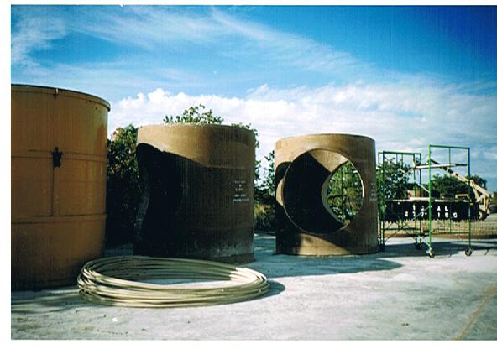

Flow Rate
Approximate Maximum Flow Rates

The flow rate for a circular pipe flowing full is given by the formula:

Q = (D^{8/3} x S^{1/2}) / (n x 1.33)

Q = Flow in cubic Feet Per Second (CFS)
D = Pipe Diameter In Feet
S = slope in decimal (i.e. 0.01)
N = Manning’s Coefficient

A circular pipe actually reaches its peak capacity when the pipe is slightly less than full. The peak capacity is approximately 14% greater than the formula above. Manning’s coefficient is dependent on the material and condition of the pipe. Typical design values are provided in the table below.

Kind of Pipe | From | To
Clean Conted Cast Iron | 0.012 | 0.014
Concrete - Rough | 0.016 | 0.017
Concrete Dry Mix | 0.015 | 0.016
Concrete Wet Mix | 0.012 | 0.014
Concrete Smooth | 0.011 | 0.012
Vitrified Clay | 0.013 | 0.015

The approximate range for “n” values for iNTERpipe is from 0.012 to 0.014.

Test Data prepared by MAXIM Technologies, Inc.

Test Data

Laboratory Analysis of Polymer Concrete

Report Date: September 24,1998

Test  % Absorption as per ASTM C301 | Results  0.7 %
% Acid-soluble matter as per ASTM C301 | 0.0019 %
Abrasion Resistance as per ASTM C944  Applied load = 20 lbf @ 3 min.  Mass loss after 1st run  Mass loss after 2nd run  Mass loss after 3rd run  Total mass loss | 0.003 %  0.006 %  0.008 %  0.008 %

Test Data prepared by MAXIM Technologies, Inc.

POLYMER CONCRETE PIPE
36 – Inch Diameter Design Calculations

Introduction:

These calculations have been prepared by Maxim Technologies, Inc. for Polymer Pipe Technology. The purpose of the calculations is to determine the expected performance of PPT’s 24-inch Diameter jacking pipe constructed of polymer concrete. The numbers in parentheses at the end of each section are applicable to the special case of a 25-inch diameter pipe with a wall thickness of 2.25-inches.

Assumptions:

The jacking pipe will have a nominal inside diameter of 24-inches. The wall thickness has been selected as 2.25-inches. Material properties are:

Ultimate Compressive Strength (f_{c}) = 9300 psi
Maximum Tensile Strength (f_{t}) = 2000 psi
Modulus of Elasticity = 1,300,000 psi
Yield Stress of Wire Reinforcement (f_{y}) = 65,000 psi

Method:

The flexural strength of the wall sections is estimated using conventional reinforced concrete ultimate strength theory. The moment capacity of the wall is given by:

M_{u} = pbd²f_{y}(1-0.59(pf_{y}/f_{c}))
Where:
M is the moment capacity (varies)
P is the steel ratio (varies)
B is the unit width (12 inches for all cases)
D is depth to steel (varies)
f_{y} is the yield stress of the steel (65,000 psi)
f_{c} is the ultimate compressive strength of the concrete (9300)

No strength or load factors are used since the intent of the calculations is to develop designs to meet specific destructive test requirements of ASTM C – 76. This analysis has been shown to be conservative on past tests of PCP with these properties.

Applied Loads and Resulting Cross Section Moments:

ASTM C 76 specifies a D-Load for concrete pipe based on the class of service. Services are classified into categories I through V. The majority of pipe used is in classes III and IV. The moments resulting from the applied D-Load may be estimated by:

M₍₊₎ = 0.3183 PR and
M₍₋₎ = 0.1817 PR
Where:
M₍₊₎ ₌ Maximum Positive Moment (at Crown)
M₍₋₎ = Maximum Negative Moment (at Spring Line)
P = The applied D-Load (per unit length of pipe)
R = Pipe Radius

The resulting D-Loads, M₍₊₎, and M₍₋₎ are shown in Table 1.

Class | D-Load (pounds) | M₍₋₎ (inch-kips) | M₍₋₎ (in-kips)
III | 6000 | 34.4 | 19.6
IV | 9000 | 51.6 | 29.4
V | 11,250 | 64.5 | 36.7

The positive moment is carried by the inner layer of steel and negative moment by the outer layer of steel. A single layer of steel formed into an ellipse may also be used. The latter approach has been selected for this application.

Design of Cross Section and Reinforcement:

Based upon preliminary analysis and manufacturing efficiencies a standard wall thickness of 2.75 – inches has been selected. Allowing for ¾ - inch of clear cover on the inside allows setting a depth of 1.5”.

The resulting wire sizes, spacing steel area per foot and resulting moment capacity are shown in Table 2 below. The steel has been sized to resist the Maximum Positive moment from Table 1. The same steel area will be more than adequate for the negative moments when the cage is formed into an ellipse.

The longitudinal steel shall be W3 on a minimum of 8-inch spacing to assist in the resistance of cracking during handling and to ease in fabrication.

Class | W.S. and spacing | Steel Area (sq. in. per foot) | +Moment Capacity (in-kips) | - Moment Capacity (in-kips)
III | W9 @ 3” | 0.36 | 38.0 | 32.2
IV | W9 @ 2” | 0.54 | 54.9 | 46.1
V | W11 @ 2” | 0.66 | 65.3 | 55.0

Test data prepared by MAXIM Technologies, Inc.

PPT Specification for Reinforced Polymer Concrete Pipe.
Note: This is an iNTERpipe specification and should not be construed as anything else.

This specification covers steel reinforced polymer concrete pipe, 18 inch through 120 inch, intended for use in gravity-flow systems for conveying sanitary sewage, storm water, and industrial wastes.

Although this specification is suited primarily for pipe to be installed in direct burial, microtunnel and pipe jacking, it may be used to the extent applicable for other installations such as, but not limited to sliplining and rehabilitation of existing pipelines.

Note: The values stated in inch-pound units are to be regarded as the standard.

1. Significance and Use
A. Meaning and Suitability –The tests called for herein, from their results, indicate the suitability and acceptability of polymer concrete pipe with embedded reinforcement for specifications acceptance, design purposes, regulatory statutes and manufacturing quality control.

B. Direct Burial Pipe – Polymer Concrete Pipe with embedded reinforcement manufactured for direct burial applications shall be of five classes identified as Class I, Class II, Class III, Class IV, and Class V. The corresponding strength requirements per pipe classification shall be in accordance with Table 1.

C. Microtunnel and Jacking Pipe – Polymer Concrete Pipe with embedded reinforcement manufactured for jacking or micro-tunneling applications shall meet the minimum strength requirements of Table 2.

2. Materials and Manufacture
A. Wall Composition – The wall composition shall consist of a thermosetting resin, aggregate, and steel reinforcement required to meet the strength requirements of Tables 1 and 2.

B. Resin – A thermosetting resin.

C. Aggregate – Siliceous sand, graded aggregates, and mineral fillers tested in accordance with requirements of Standard Test Methods C-33, C-117 and C-136, except that the requirements for gradation shall not apply.

D. Joints – The pipe shall have a gasket sealed joining system that shall prevent leakage of the contained fluid under the intended service condition.

E. Couplings and Sealing Rings – stainless steel or a glass fiber reinforced thermosetting resin coupling ring, which uses an elastomeric seal.

F. Gaskets – Elastomeric seals (gaskets) used with this pipe shall conform to the requirements of Specifications C-443-94, except that composition of the elastomer shall be as agreed upon between the purchaser and the supplier as being resistant to the intended chemical environments.

G. Compression Rings – A compression ring shall be used between pipe sections to avoid damage to pipe sections or seals when the pipe is installed by jacking.

H. Embedded Reinforcement – Reinforcement shall consist of steel wire conforming to ASTM Specification A 82 or Specification A 496 or of steel wire fabric conforming to ASTM Specification A 185 or Specification A 497 or of bars of Grade 40 steel conforming to ASTM Specification A 615.

3. Requirements
A. Workmanship – Each pipe shall be free from all defects, including indentations, cracks, foreign inclusions and resin-starved areas that, due to their nature, degree or extent, detrimentally affect the strength and serviceability of the pipe. The pipe shall be as uniform as commercially practical in color, opacity, density and other physical properties.

B. The inside surface of each pipe shall be free of bulges, dents, ridges, and other defects that result in a variation of inside diameter of more than 1/8 in. (3.2 mm) from that obtained on adjacent unaffected portions of the surface.

C. Joint sealing surfaces shall be free of dents, gouges and other surface irregularities that will affect the integrity of the joints.

4. Dimensions
A. Pipe Diameters – The pipe shall be supplied in the nominal diameters as required in the plans.

B. Lengths – Pipe shall be supplied in nominal lengths as described in Section 7, unless otherwise agreed to between purchaser and seller.

C. Wall Thickness – The pipe shall be supplied with the wall thickness required to meet D-Load requirement as shown in Tables 1 and 2, unless otherwise agreed to between purchaser and seller.

D. Straightness of Pipe – Pipes shall not deviate from straight by more than the amount shown in Section 7 of this specification.

E. Roundness of Pipe – The diameter shall not vary from a true circle by more than 1.0% of its nominal diameter.

- Squareness of Pipe Ends – The end squareness shall be as described in Section 7.

5. Test Methods

A. Three edge bearing – The pipe shall withstand, without failure, the three-edge bearing loads specified in Tables 1 and 2.

B. Compressive Strength – The minimum axial compressive strength shall be 9,000 psi. Determine in accordance with ASTM Test Method C-579 Method B. Obtaining test samples via drilled core and / or sawed beams are to follow ASTM Standard Test Method and procedures of C 42 for cores and / or C 109 for cubes.

C. Hydrostatic Pressure – The pipe shall withstand an internal pressure of 10 psi for a minimum of 15 minutes, when tested in accordance with Stand Test Method C-301 or as required by intended service.

D. Acid Resistance – This test is used to determine the resistance of the pipe to the action of acids specified in ASTM Test Methods C-301. The test shall be performed only when specified.

The pipe of each size and shipment shall be acceptable if the percent acid-soluble matter, from specimens representing such pipe, does not exceed 0.25%.

E. Joint Tests – The pipe shall meet the requirements described in ASTM Specifications C361-96, C443-94, and/or C1208-95 depending on which application the pipe will be used for and what service the pipe will be placed in.

6. Sampling and Test Specimens

A. Test Specimen - Test specimens of the pipe to be used may be selected by the purchaser, and/or their representative from the manufacturer’s stock lot.

B. Stock Lot - For the purpose of these specifications, a lot is defined as no more than 100 sections of pipe of each size and class furnished.

The number of specimens to be tested shall not exceed 0.5% of the number of pipe of each size furnished, except that no less than two specimens shall be tested.

If any of the test specimens fail to meet the requirements outlined in this specification, the manufacturer will be allowed to retest two additional specimens representative of the original material stock lot for each one that failed. The stock lot will be acceptable if all retest specimens meet the test requirements.

C. Production Tests – Select one pipe at random from each lot to determine conformance of the material to the workmanship, dimensional and physical requirement of this outlined specification.

D. Qualification Tests – Sampling for qualification tests is not required unless otherwise agreed upon between the purchaser and the supplier. Qualification tests for which a certification and test report shall be furnished when requested by the purchaser, including the following: Hydrostatic pressure test, Acid resistance test and Joint-tightness test.

7. Dimensions and Tolerances - The permissible variations in dimensions shall be limited to the following:

A. Length – Pipe shall have a nominal laying length of 8 to 24 feet unless otherwise specified. Measure the pipe with a steel tape or gage having gradations of 1/16 in. or less. Lay the tape or gage on or inside the pipe and measure the overall laying length of the pipe. Variations in laying lengths of two opposite sides of pipe shall not be more than 1/16 inch per foot (5mm per m) with a maximum of ½ inch in any length of pipe.

B. Wall Thickness – Pipe wall thickness will be identified by the manufacturer and be adequate to meet the requirements of the loadings specified in Tables 1 and 2.

C. Inside Diameter – The inside diameter of 12 to 14 inches (300 to 600mm) pipe shall not vary more than ¼ inch (6mm). The internal diameter of 27 inches (675 mm) and larger pipe shall not vary more than 1% or 5/8 inch (16mm), whichever is less.

D. Straightness – Pipes shall not deviate from straight by more than 1/16 inch per linear foot (5mm per linear meter). Measurements shall be taken by measuring gaps between the pipe wall ends and a straightedge placed along any longitudinal line on the exterior surface of the pipe.

E. Roundness – The outside diameter of the pipe shall not vary from a true circle by more than 1%.

F. End Squareness – the ends of the pipe in contact with the jacking pads shall be perpendicular to the longitudinal axis of the pipe with a maximum of ½ inch (13mm), measured with a square and a straight edge across the end of the pipe. The bearing surfaces shall be smooth and free of projections.

Note: For pipe jacking installations, tolerances for squareness and straightness of pipe may be more stringent.

8. Reinforcement
A. Circumferential Reinforcement – Determined in accordance with ASTM C 76 Section 8.1.

B. Longitudinal Reinforcement – Determined in accordance with ASTM C 76 Section 8.2.

C. Joint Reinforcement – Determined in accordance with ASTM C 76 Section 8.3.

9. Repairs
Pipe may be repaired, if necessary, because of imperfections in manufacture or damage during handling and will be acceptable if, in the opinion of the owner, the repaired pipe conforms to the requirements of this specification.

10. Packing, Marking and Shipping
Mark each length of pipe that meets or is part of a lot that meets the requirements of this specification at least once in letters not less than ½ inch in height and of bold type style in a color and type that remains legible under normal handling and installation procedures. The marking shall include the nominal pipe size, manufacturer’s name or trademark, any ASTM specification number required or specified, three-edge bearing strength and maximum allowable jacking force, if applicable.

Prepare pipe for commercial shipment in such a way as to ensure acceptance by common or other carriers.

All packing, packaging, and marking provisions of Practice D-3892 shall apply to this specification.

Table 1 Design Requirements for Direct Burial Pipe

The strength test requirements in pounds-force per linear foot of pipe under the three-edge bearing method shall be either the D-load (test load expressed in pounds-force per linear foot per foot of diameter) to produce a 0.01-in crack, or the D-loads to produce the 0.01-in, crack and the ultimate load as specified below, multiplied by the internal diameter in the pipe in feet.

Classification | D-Load to produce a 0.01” crack | D-Load to produce ultimate load
Class I | 800 | 1200
Class II | 1000 | 1500
Class III | 1350 | 2000
Class IV | 2000 | 3000
Class V | 3000 | 3750

Table 2 Design Requirements for Jacking Pipe
The strength test requirements in pounds-force per linear foot of pipe under the three-edge bearing method shall be either the D-load (test load expressed in pounds-force per linear foot per foot of diameter) to produce a 0.01-in crack, or the D-loads to produce the 0.01-in, crack and the ultimate load as specified below, multiplied by the internal diameter in the pipe in feet.

Pipe Size | D-Load to produce a 0.01” crack | D-Load to produce ultimate load
21” Inside Diameter and Smaller | 2000 | 3000
24” Inside Diameter and Greater | 1350 | 2000

11. Terminology (Definitions):
General– Unless otherwise indicated, definitions are in accordance with Definitions C-125, D-883, C-822-93, C-904-97, and F-412, and abbreviations are in accordance with Terminology D-1600.

Description of Terms Specific to This Standard:
Aggregate-a siliceous granular material, such as sand, gravel, crushed stone and mineral filler, conforming to the requirements of ASTM C 33 except that the requirements for gradation shall not apply.

Polymer concrete pipe – tubular product consisting of aggregate, embedded in or surrounded by cured thermosetting resin and which may contain granular or platelet fillers, thixotropic agents, pigments, or dyes.

Reinforced Polymer Concrete Pipe – is a polymer concrete pipe with embedded reinforcement such as steel wire, steel wire mesh and / or steel bar.

Qualification test – one or more tests used to prove the design of a product. Not a routine quality control test.

Pipe Jacking – a system of directly installing pipes behind a shield machine by hydraulic jacking from a drive shaft, such that the pipes form a continuous string in the ground.

Referenced Documents (ASTM Standards):
A 82 Specification for Steel Wire, Plain, for Concrete Reinforcement.

A 185 Specification for Steel Welded Wire, Fabric, Plain, for Concrete Reinforcement.

A 496 Specification for Steel Wire, Deformed, for Concrete Reinforcement.

A 497 Specification for Steel Welded Wire Fabric, Deformed, for Concrete Reinforcement.

A 615 Specification for Deformed and Plain Billet-Steel, for Concrete Reinforcement.

C-33 Standard specification for concrete aggregates.

C-42 Standard Test Method for Obtaining and Testing Drilled Cores and Sawed Beams of Concrete.

C-76 Standard specification for reinforced concrete culvert, storm drain, and sewer pipe.

C-109 Standard Test Method for Compressive Strength of Hydraulic Cement Mortars (Using 2-in. or (50-mm) Cube Specimens).

C-117 Standard Test Methods for Materials Finer than 75um (No.200) Sieve in Mineral Aggregates by Washing.

C-125 Standard Terminology Relating to Concrete and Concrete Aggregates.

C-136 Standard Method for Sieve Analysis of Fine and Coarse Aggregates.

C-301 Standard test methods for vitrified clay pipe.

C-361-96 Standard specification for reinforced concrete low head pressure pipe.

C-443-94 Standard specification for joints for circular concrete sewer and culvert pipe, using rubber gaskets.

C-497 Standard test methods for concrete pipe, manhole sections, or tile.

C-579 Compressive strength of chemical-resistant mortars, grouts, monolithic surfacings, and polymer concretes.

C-822 Standard terminology relating to concrete pipe and related products.

C-904 Standard terminology relating to chemical-resistant nonmetallic materials.

C-1208 Standard Specification for Vitrified Clay Pipe and Joints for use in Jacking, Sliplining, and Tunnels.

D-883 Standard Terminology Relating to Plastics.

D-1600 Terminology for Abbreviated Terms Relating to Plastics

D-3892 Practice for Packaging/Packing of Plastics.

F-412 Standard Terminology Relating to Plastic Piping Systems.
Polymer Concrete Pipe Specification
Manufactured By: Polymer Pipe Technology / iNTERpipe.

This specification applies to polymer concrete microtunneling pipe manufactured by Polymer Pipe Techonoly to be used for sanitary sewers, storm drains, and related structures. The pipe shall be manufactured in accordance with ASTM C-1208 and ASTM C-76. A minimum allowable compression strength to meet and / or exceed the strength requirements of ASTM C-76 Class V pipe is required (Section 7.2 of ASTM C-76-95a under “modified or Special Designs” (7.2.2 and 7.2.3). The size of the polymer concrete pipe to be furnished shall be manufactured to meet the requirements as shown on the Plans and / or the Specifications. The jacking load for the pipe shall be as determined by the Contractor for geotechnical conditions presented in the Geotechnical Report.

Materials Requirement: The wall resin shall be polyester. The aggregate shall conform to a maximum grain size of 5/8 inch. The sand shall have a maximum grain size of 16 mesh. The filler shall be an inert powder. The aggregate, sand and inert powder shall be cleaned, washed and dried. The pipe shall meet the chemical requirements of continuous service in a sanitary sewer environment ranging from pH 1 to pH 10. Elastomeric sealing gaskets shall conform to the requirements of either ASTM F-477 and / or ASTM C-443.

Dimensions and Tolerances. Dimensions and size of pipe shall conform to requirements set below:

- Length. The pipe lengths shall have a maximum length of 10 feet, or as agreed upon by manufacturer and owner.

- Minimum Wall Thickness. The minimum wall thickness shall be as needed to support the anticipated jacking forces with a factor of safety of 3.0 at the joints.

- Out of Straight. Pipes shall not deviate from straight by more than 0.06 inch per linear foot. Measurement shall be taken by measuring the gaps between the pipe wall and a straight edge placed along any longitudinal line on the pipe’s exterior surface.

- Out of Round. The inside and outside diameters shall not vary from a true circle by more than 0.5 percent of its designed diameter. The out-of-round dimensions are the difference between the maximum and minimum diameters measured at any one location along the barrel. The compression disc shall be installed in the bell end of the pipe at the factory as part of the manufacturing process.

- Out of Square. The ends of the pipe shall be perpendicular to the straight long axis within 0.004 inch per inch of outside diameter.

- Diameter. The inside diameter of the pipe shall not vary by more than 1% or 5/8 whichever is less.

Joints: Joints for the polymer concrete microtunneling pipe shall consist of a seat, an elastomeric sealing element, a sleeve, and a compression disc.

- Seat. The seat is either a formed or ground recess on the pipe ends.

- Elastomeric Sealing Element. The elastomeric sealing element is an elastomeric gasket whose configuration and location may vary with pipe diameter and will provide a watertight joint at allowed deflection angles and after compression from tunneling operations.

- Sleeve. The sleeve is an element which bridges between pipe sections. The sleeve shall be made of a noncorrosive material such as fiberglass which in conjunction with the sealing element forms a joint which meets the performance requirements of ASTM D-4161 and / or ASTM C-1208. Composite sleeve shall be corrosion resistive in continuous service with a pH between 1 and 10. Sleeves shall be flush to outside diameter of pipe.

- Compression Disc. The compression disc is a flat disc that conforms to the remaining ends of the pipe after the joint is formed. Its purpose is to distribute the jacking forces which develop during pipeline installation. The width of the compression disc shall not exceed the maximum wall thickness of the pipe at the joint, nor shall it extend into the spigot end of the connecting pipe. Compression discs shall be factory fabricated and installed.

Testing Requirements. Testing shall be in accordance with ASTM C-1208 and ASTM C-76 Class V pipe.

Joint Tests. Joint tests shall be in accordance with ASTM D-4161 and / or ASTM C-1208 depending on engineer’s requirements.

Bearing Strength Test. The bearing strength shall be tested in accordance with ASTM C-301 and / or ASTM C-76. Required bearing strength shall be a minimum of 3000 lb/ft.

Compression Strength Test. The compressive strength shall be tested in accordance with ASTM C-579 Method B, ASTM C-1208 and / or ASTM C-497. If the compression samples to be tested are to be taken from a pipe, compressive strength shall be tested in accordance with ASTM C-42 for cores and / or ASTM C-109 for cubes. The compressive strength shall be a minimum to meet or exceed ASTM C-76 Class V pipe requirements. The pipe test section shall be completely immersed in water for a minimum of 24 hours immediately prior to the compression tests (three edge-bearing tests).

Marking. Each pipe section shall be marked on both ends to identify the manufacturer, manufacturer number (identifies factory location, date of manufacture, shift, and sequence), nominal diameter, beam load, ASTM number and designation, and lot number.

Polymer Pipe Technology iNTERpipe

PPT Specification for Precast Reinforced Polymer Concrete Manhole Sections

Note: This is an iNTERpipe specification and should not be construed as anything else.

This specification applies to precast reinforced rigid polymer concrete manufactured by Polymer Pipe Technology to be used for sanitary sewers, storm drains, and related structures. The manholes shall be manufactured in accordance with ASTM C 478 (7.2 Modified and Special Design) and risers in accordance with ASTM C 76 (Section 7.2 of ASTM C 76-95a under Modified or Special Designs” 7.2.2 and 7.2.3). The size of the polymer concrete manholes to be furnished shall be manufactured to meet the requirements as shown on the Plans and/ or Specifications.

Significance and Use
Meaning and Suitability –The tests called for herein, from their results, indicate the suitability and acceptability of polymer concrete manhole with embedded reinforcement for specifications acceptance, design purposes, regulatory statutes and manufacturing quality control.

Materials and Manufacture
Wall Composition – The wall composition shall consist of a thermosetting resin and aggregate, and internal reinforcement.

Aggregate – Siliceous sand, graded aggregates, and mineral fillers tested in accordance with requirements of Standard Test Methods C-33, C-117 and C-136, except that the requirements for gradation shall not apply.

Joints – The reinforced concrete manhole base and riser sections, excepting grade rings, shall be designed and formed with male and female ends, so that when the manhole base, riser, and top are assembled they will make a continuous and uniform manhole.

Elastomeric Seals (Gaskets) – Elastomeric seals (gaskets) used with this pipe shall conform to the requirements of Specifications C-443. Except that composition of the elastomer shall be as agreed upon between the Engineer and the supplier as being resistant to the intended chemical environments.

Embedded Reinforcement – Reinforcement shall consist of steel wire conforming to ASTM Specification A 82 or Specification A 496 or of steel wire fabric conforming to ASTM Specification A 185 or Specification A 497 or of bars of Grade 40 steel conforming to ASTM Specification A 615.

Requirements
Workmanship – Each pipe shall be free from all defects, including indentations, cracks, foreign inclusions and resin starved areas that, due to their nature, degree or extent, detrimentally affect the strength and serviceability of the pipe. The pipe shall be as uniform as commercially practical in color, opacity, density and other physical properties.

Joints – The pipe shall meet the requirements described in ASTM Specifications C 443. Pipe to manhole connections shall have flexible, resilient and noncorrosive boot connectors or ring waterstops acceptable to the Engineer or designated representative conforming to the requirements of ASTM C 923 on all wastewater manhole connections.

Joint sealing surfaces shall be free of dents, gouges and other surface irregularities that will affect the integrity of the joints.

Sampling and Test Specimens
Test Specimen - Test specimens of the pipe to be used may be selected by the purchaser, and/or their representative from the manufacturer’s stock lot.

Stock Lot - For the purpose of these specifications, a lot is defined as no more than 100 sections of pipe of each size and class furnished.

The number of specimens to be tested shall not exceed 0.5% of the number of pipe of each size furnished, except that no less than two specimens shall be tested.

If any of the test specimens fail to meet the requirements outlined in this specification, the manufacturer will be allowed to retest two additional specimens representative of the original material stock lot for each one that failed. The stock lot will be acceptable if all retest specimens meet the test requirements.

Production Tests – Select one pipe at random from each lot to determine conformance of the material to the workmanship, dimensional and physical requirement of this outlined specification.

Qualification Tests – Sampling for qualification tests is not required unless otherwise agreed upon between the purchaser and the supplier. Qualification tests for which a certification and test report shall be furnished when requested by the purchaser, including the following: Hydrostatic pressure test, Acid resistance test and Joint-tightness test.

Test Methods
Three-Edge Bearing Test – External load crushing strength test. The test specimens shall be standard lengths of pipe or other lengths as approved by the purchaser. Three-Edge Bearing Test will be tested in accordance with the ASTM Standard Test Methods of C-301 or C-497.

Compressive Strength Test – Determine in accordance with ASTM Test Method C-579 Method B. Obtaining test samples via drilled core and / or sawed beams are to follow ASTM Standard Test Method and procedures of C 42 for cores and / or C 109 for cubes.

Hydrostatic Pressure Test – The pipe shall meet the laboratory requirements and test procedures of ASTM Standard Test Method C-1208.

Absorption – ASTM C 301

Abrasion Resistance – ASTM C 944

Acid-Soluble Matter – This test is used to determine the resistance of the pipe to the action of acids specified in ASTM Test Methods C 301. The test shall be performed only when requested by the Engineer.

Dimensions and Tolerances - The permissible variations in dimensions shall be limited to the following:

Inside Diameter – The internal diameter of manhole sections shall not vary more than 1%.

Wall Thickness – The wall thickness shall not be less than that described in the design by more than 5% or +/- 3/16 inch, whichever is the greater. A wall thickness greater than that shown in the design shall not be cause for rejection.

Length of Two Opposite Sides – Variations in laying lengths of two opposite sides of manhole sections shall not be more than 5/8 inch.

Length of Sections – The underrun in length of a section of manhole base, riser, or conical top shall be not more than ¼ inch/foot of length with a minimum of ½ inch in any one section.

Repairs
Pipe may be repaired, if necessary, because of imperfections in manufacture or damage during handling and will be acceptable if, in the opinion of the owner, the repaired pipe conforms to the requirements of this specification.

Packing, Marking and Shipping
Mark each length of pipe that meets or is part of a lot that meets the requirements of this specification at least once in letters not less than ½ inch in height and of bold type style in a color and type that remains legible under normal handling and installation procedures. The marking shall include the nominal pipe size, manufacturer’s name or trademark, any ASTM specification number required or specified, three-edge bearing strength and maximum allowable jacking force, if applicable.

Terminology (Definitions):
General– Unless otherwise indicated, definitions are in accordance with Definitions C-125, C-822-93, C-904-97, and abbreviations are in accordance with Terminology D-1600.

Description of Terms Specific to This Standard:
Aggregate-a siliceous granular material, such as sand, gravel, crushed stone and mineral filler, conforming to the requirements of ASTM C 33 except that the requirements for gradation shall not apply.

Polymer concrete pipe – tubular product consisting of aggregate, embedded in or surrounded by cured thermosetting resin and which may contain granular or platelet fillers, thixotropic agents, pigments, or dyes.

Reinforced Polymer Concrete Pipe – is a polymer concrete pipe with embedded reinforcement such as steel wire, steel wire mesh and / or steel bar.

Qualification test – one or more tests used to prove the design of a product. Not a routine quality control test.

Referenced Documents (ASTM Standards):
A 82 Specification for Steel Wire, Plain, for Concrete Reinforcement.

A 185 Specification for Steel Welded Wire, Fabric, Plain, for Concrete Reinforcement.

A 496 Specification for Steel Wire, Deformed, for Concrete Reinforcement.

A 497 Specification for Steel Welded Wire Fabric, Deformed, for Concrete Reinforcement.

A 615 Specification for Deformed and Plain Billet-Steel, for Concrete Reinforcement.

C 33 Standard specification for concrete aggregates.

C 42 Standard Test Method for Obtaining and Testing Drilled Cores and Sawed Beams of Concrete.

C 76 Standard specification for reinforced concrete culvert, storm drain, and sewer pipe.

C 109 Standard Test Method for Compressive Strength of Hydraulic Cement Mortars (Using 2-in. or (50-mm) Cube Specimens).

C 117 Standard Test Methods for Materials Finer than 75um (No.200) Sieve in Mineral Aggregates by Washing.

C 125 Standard Terminology Relating to Concrete and Concrete Aggregates.

C 136 Standard Method for Sieve Analysis of Fine and Coarse Aggregates.

C 301 Standard test methods for vitrified clay pipe.

C 443 Standard specification for joints for circular concrete sewer and culvert pipe, using rubber gaskets.

C 497 Standard test methods for concrete pipe, manhole sections, or tile.

C 579 Compressive strength of chemical-resistant mortars, grouts, monolithic surfacings, and polymer concretes.

C 822 Standard terminology relating to concrete pipe and related products.

C 904 Standard terminology relating to chemical-resistant nonmetallic materials.

C 923 Specification for Resilient Connectors Between Reinforced Concrete Manhole Structures Pipes

C 944 Specification for Abrasion Resistance

Supplementary Information Design Data – Calculations & Test Copies

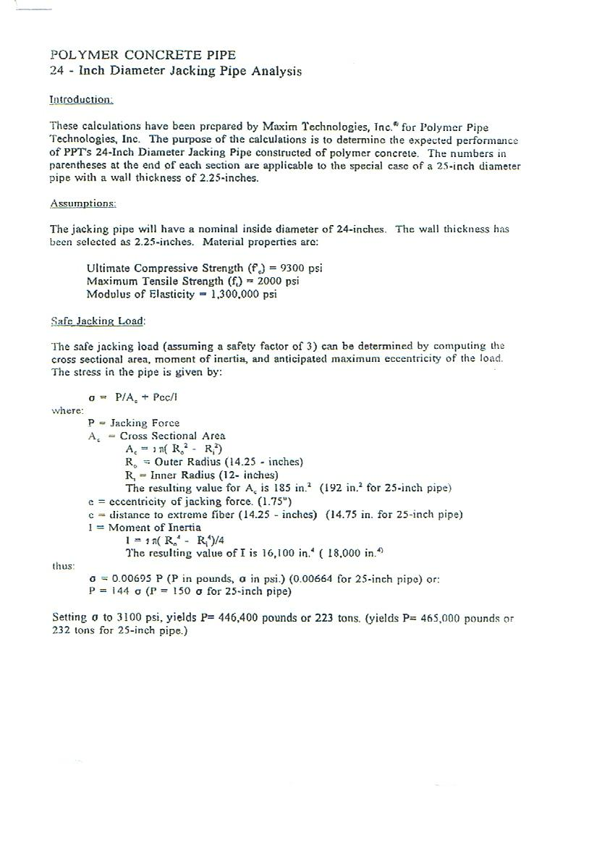

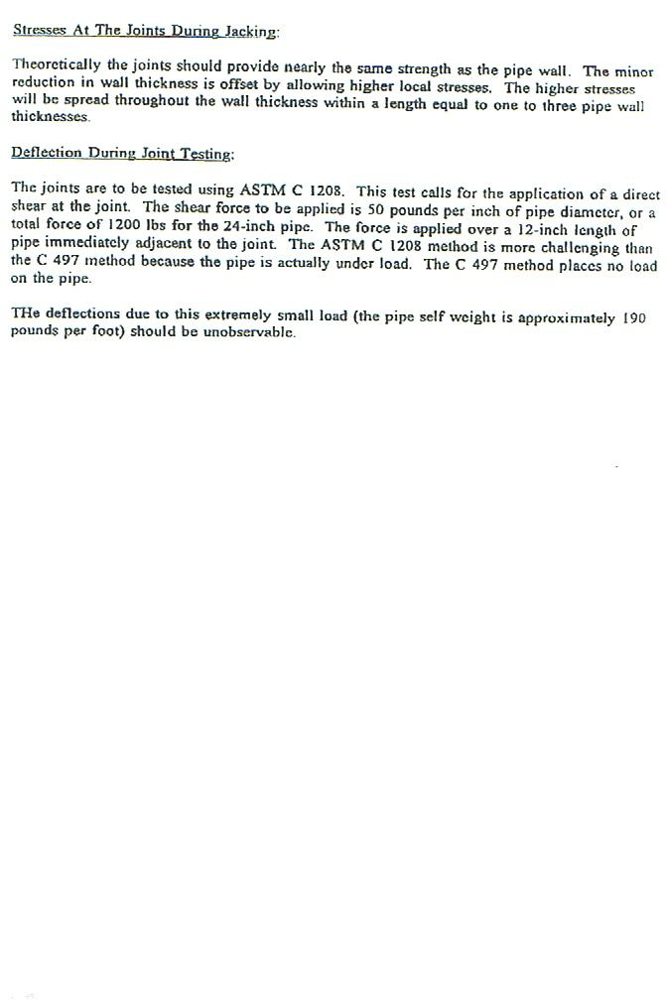
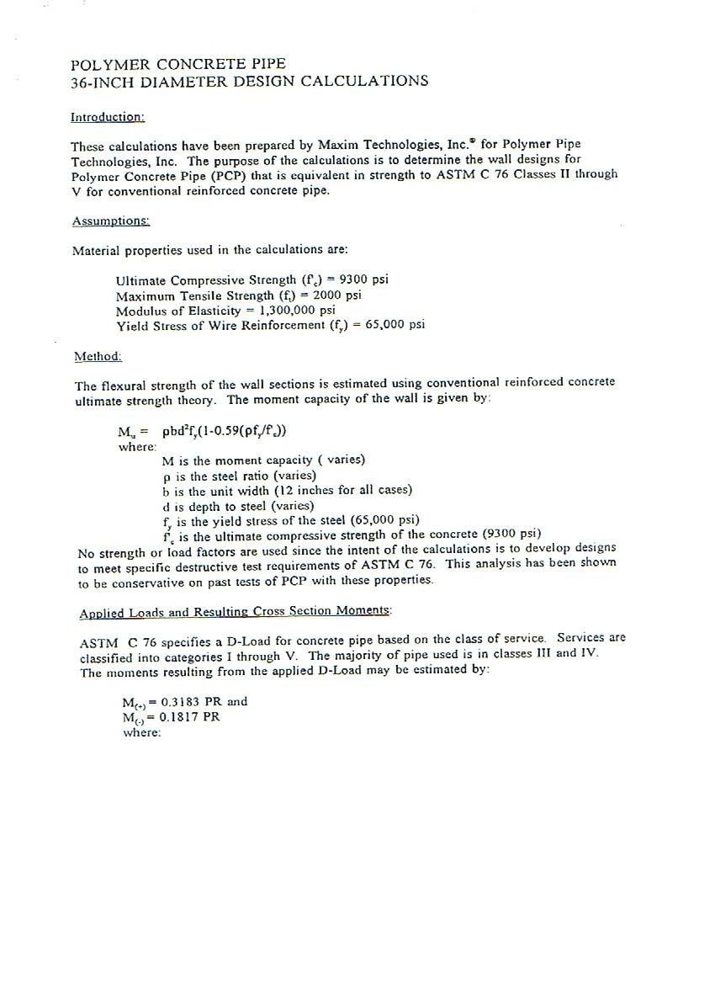

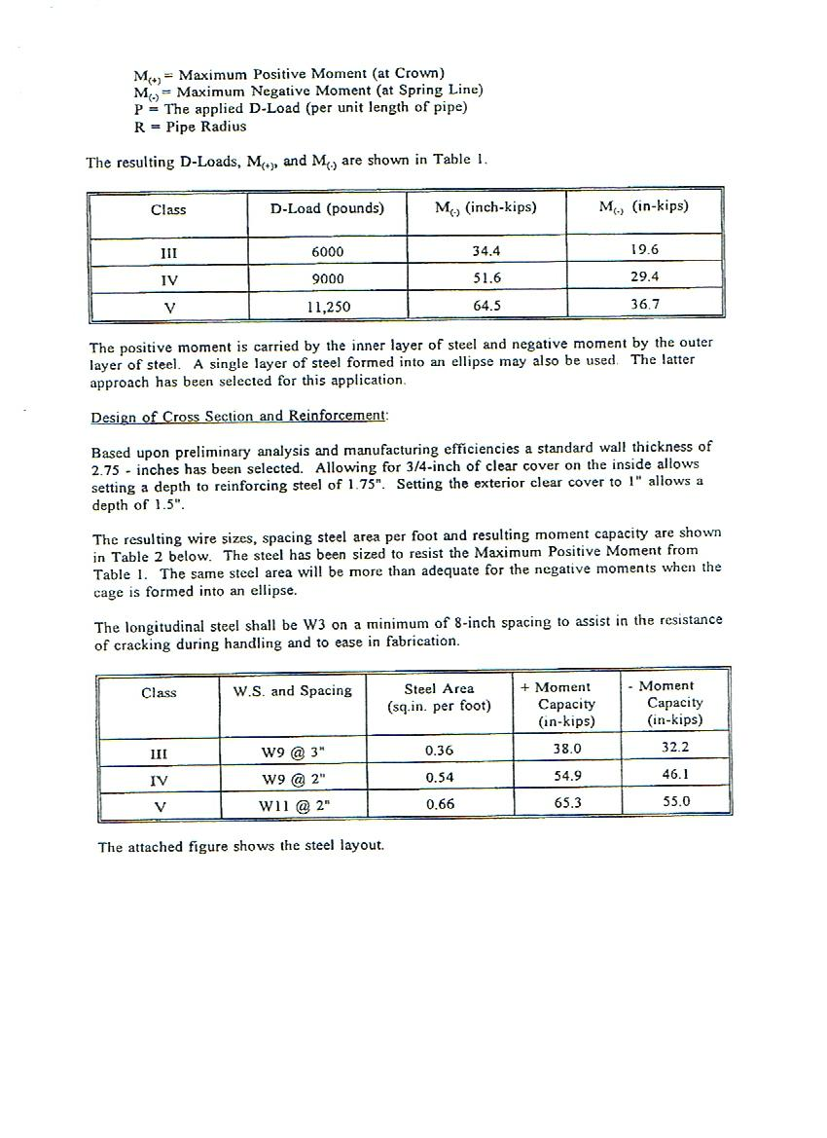

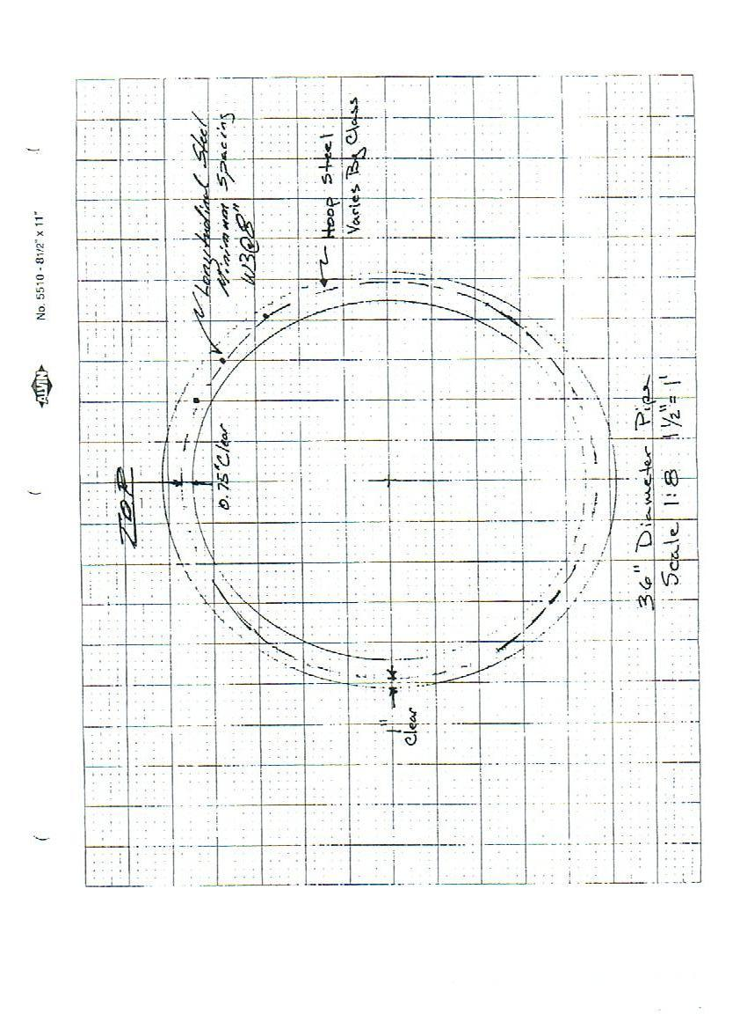

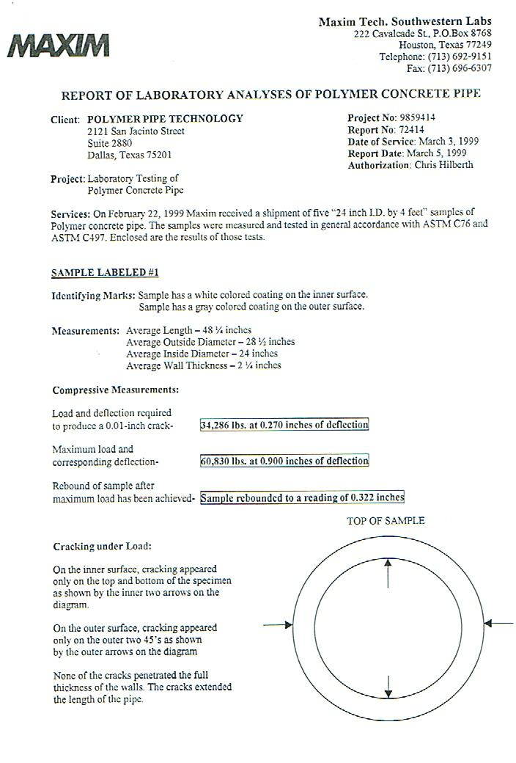
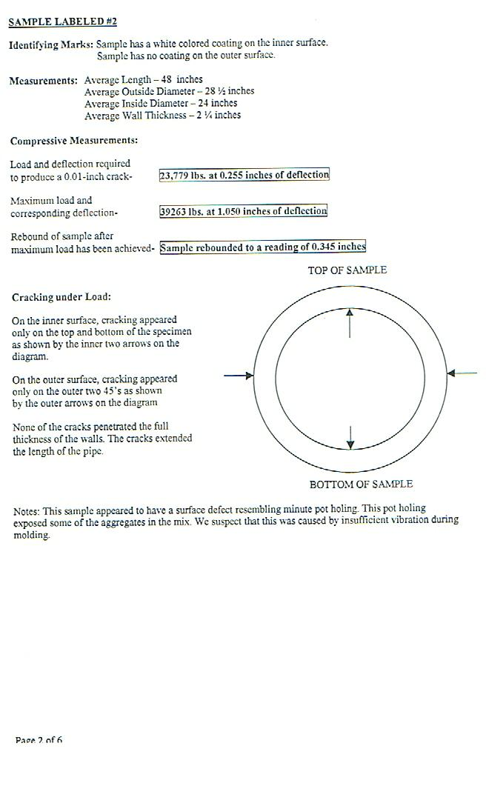
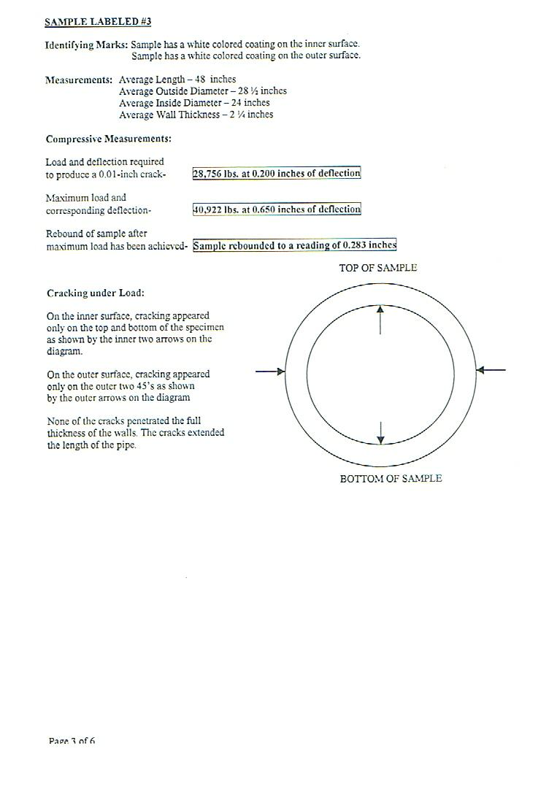
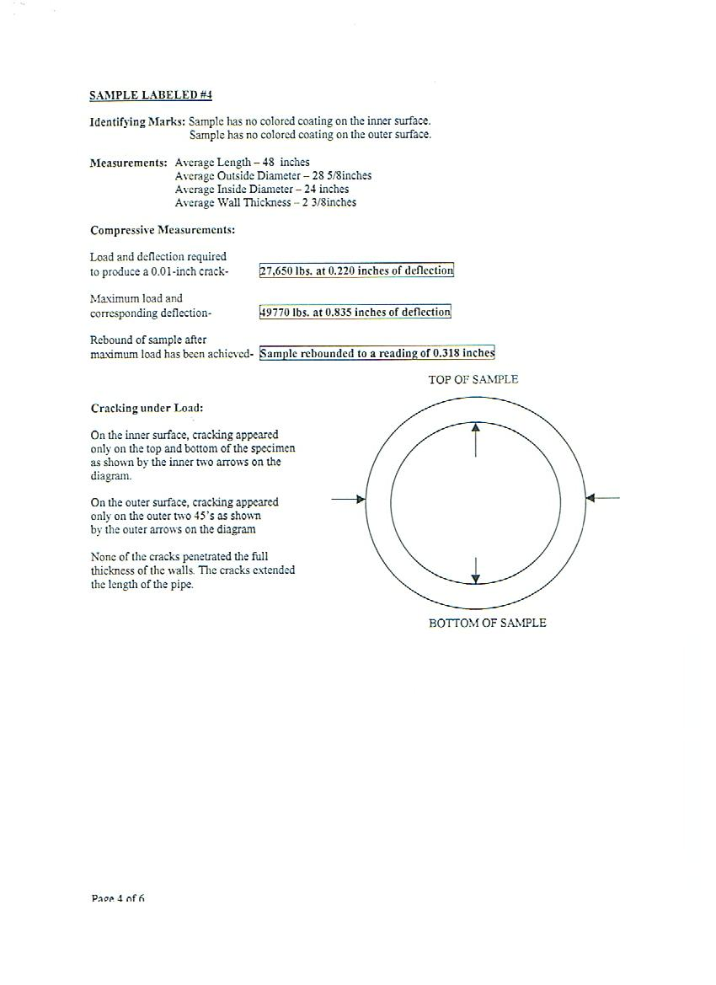

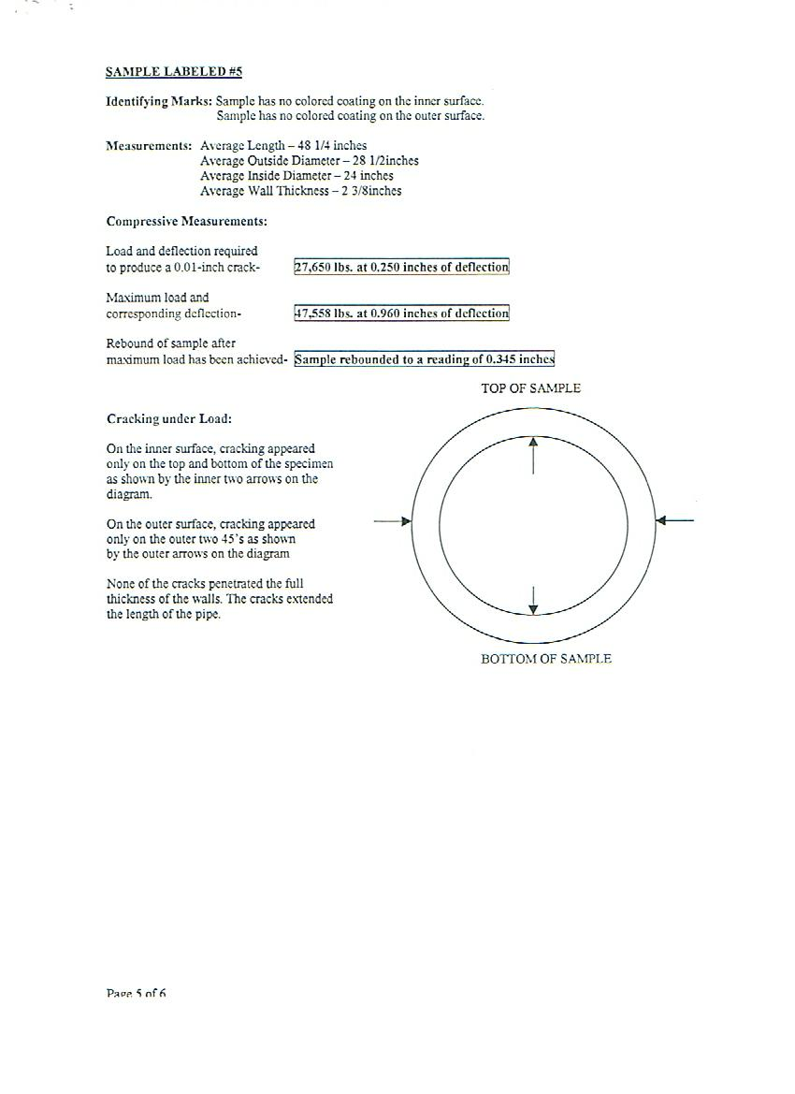

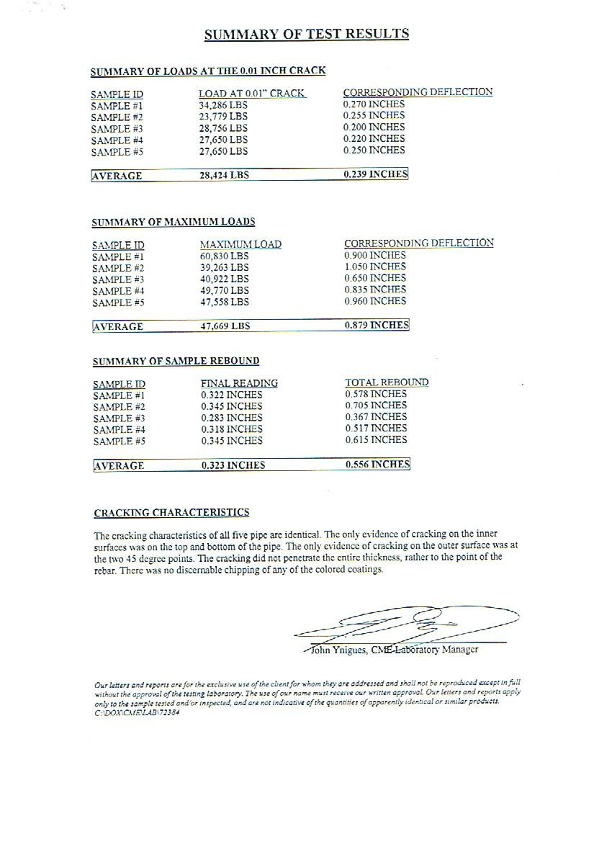

Joint Details – direct bury 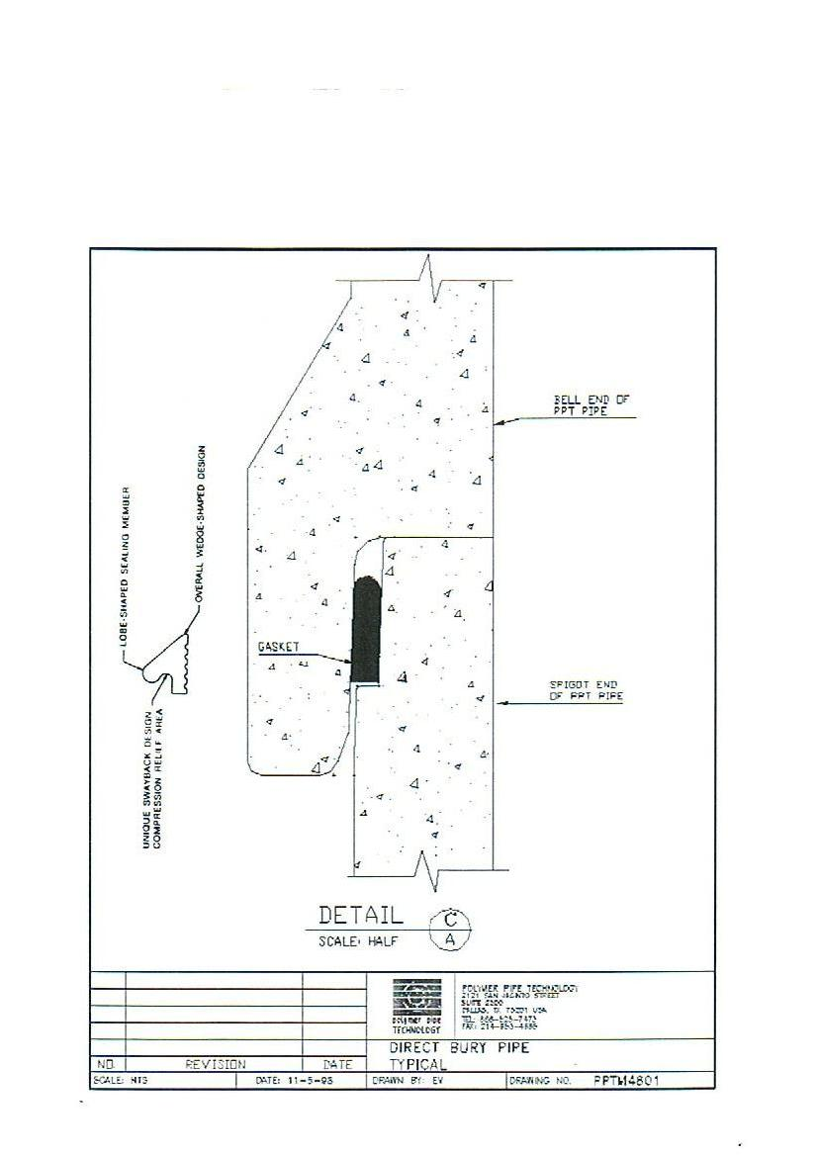

Joint Details – jacking pipe
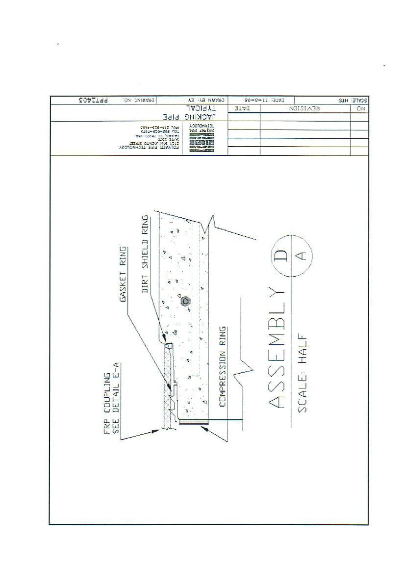

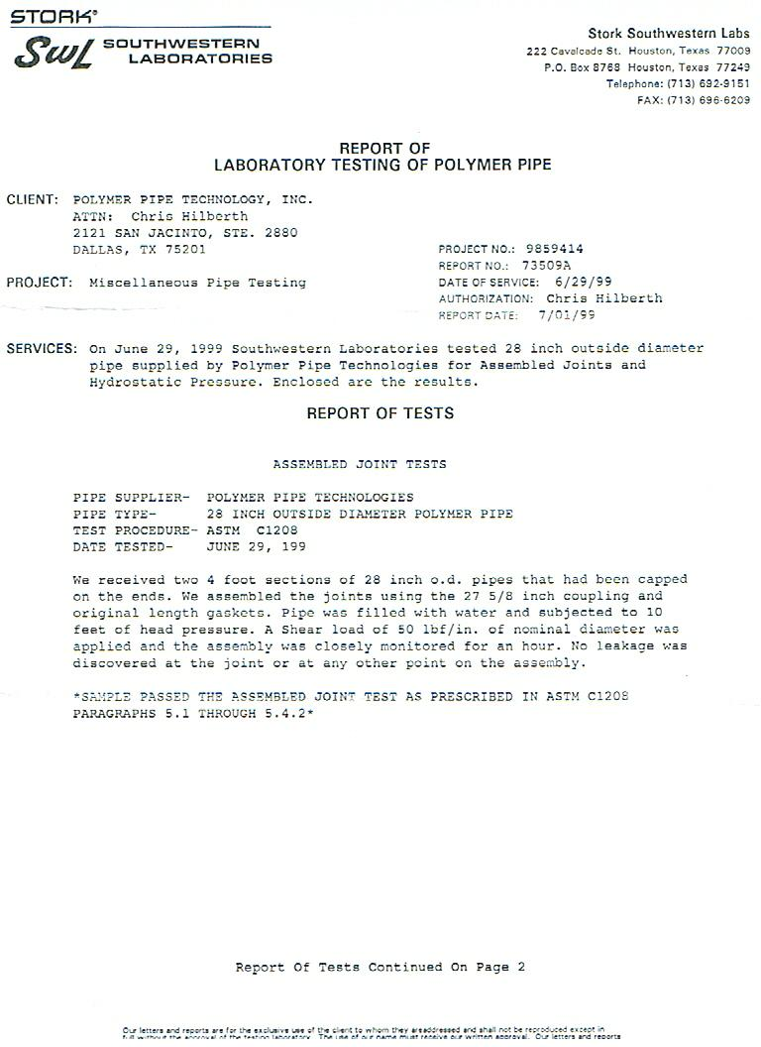

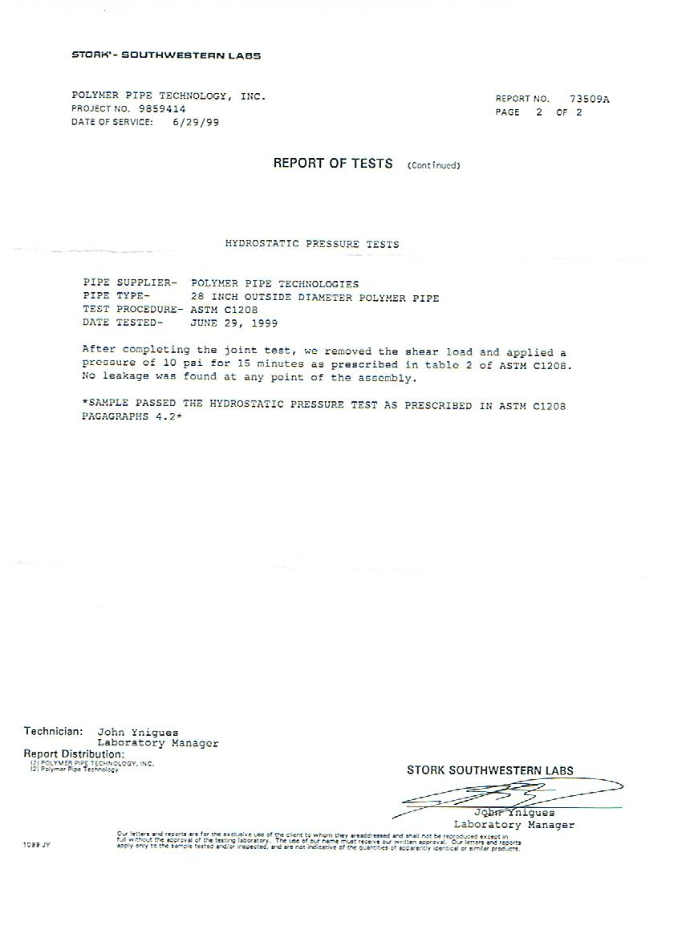

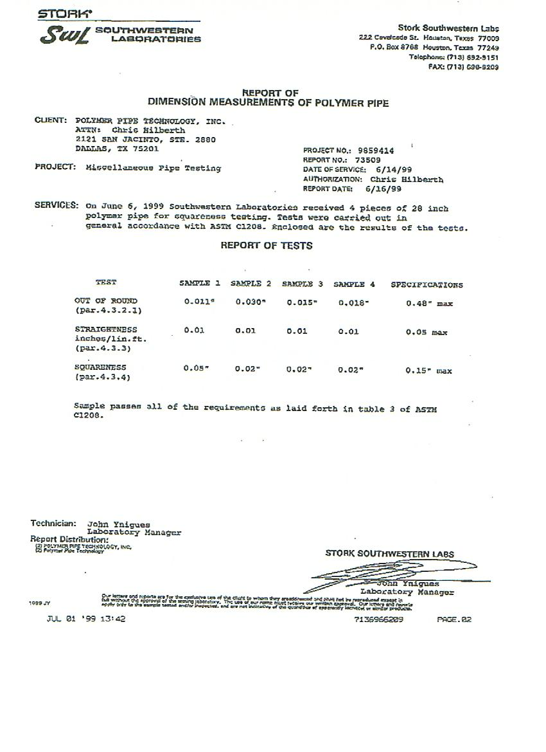

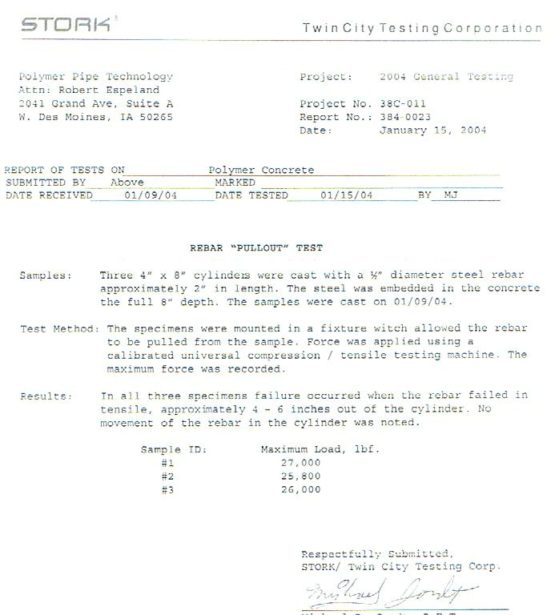

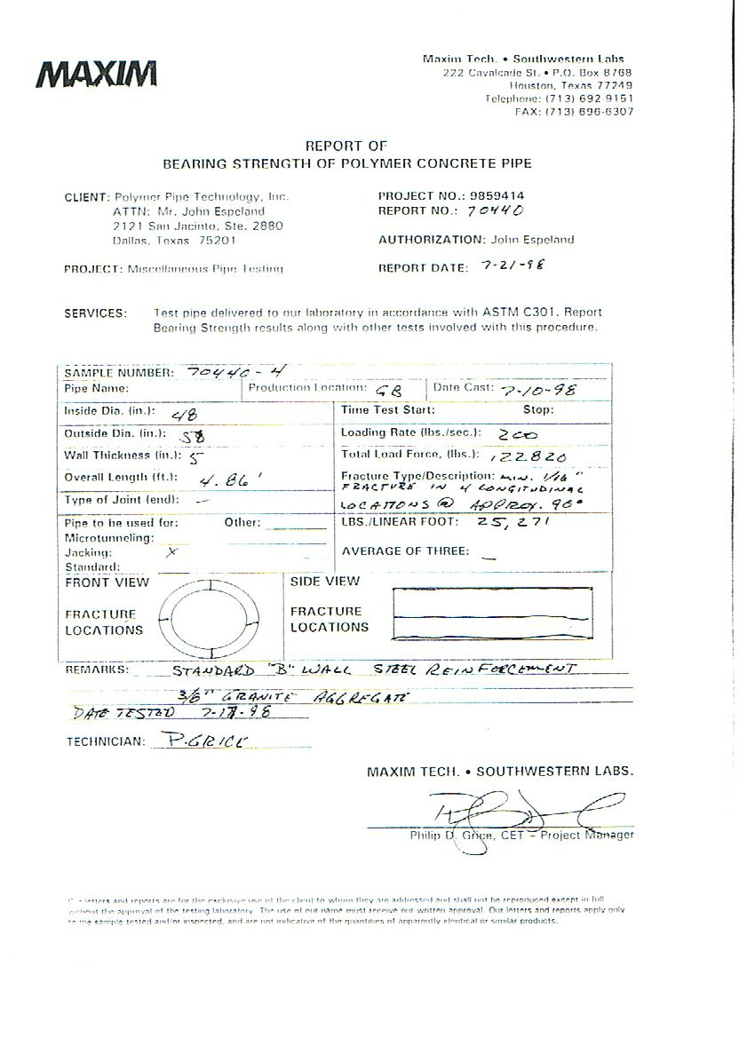

ASTM C301 / ASTM C944

